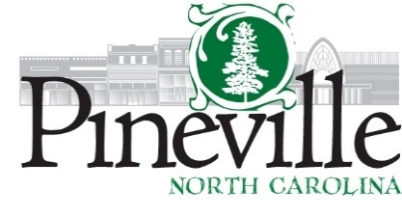
Work Session
Town Hall Council Chambers
Monday, August 26, 2024 AT 6:00 PM
https://us02web.zoom.us/j/83650994802
AGENDA
CALL TO ORDER

DISCUSSION ITEMS
1. Davenport Presentation
a. Debt issuance for Fire Department
b. Fund balance policies for General Fund
2. Review of letter to HighLine Partners
3. Discussion of Resolution and MOU for the Penny Sales Tax Legislation
4. Dorman Road Townhome Rezoning
5. Cone Mill PSA
6. Location of Hawk Signal on Main Street

ADJOURN

